JTH AGENCY CLASSIC
Contributed by Wes Bailey
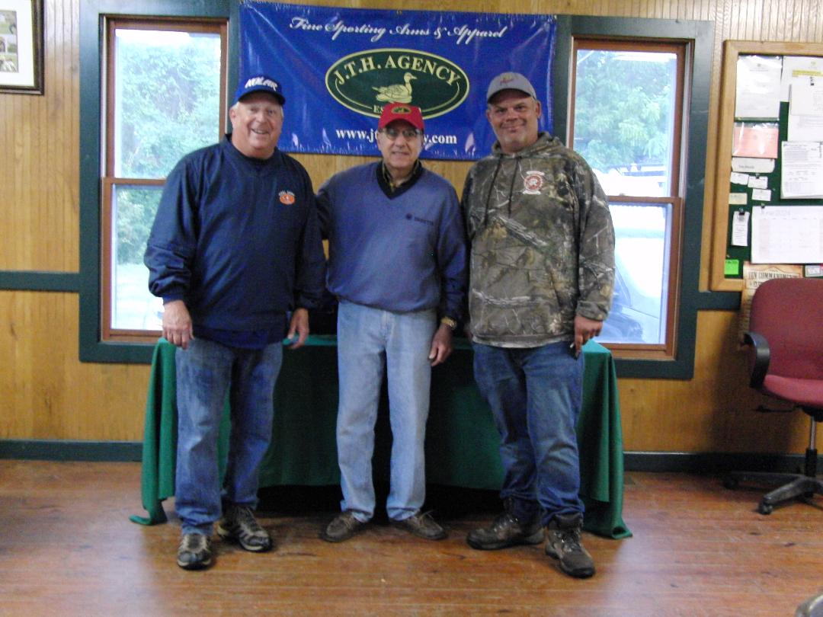

Victor, NY -- Victor Rod and Gun Club proudly hosted the 2024 JTH Agency Classic from June 7th to June 9th. This year’s event was the 35th anniversary of this registered skeet tournament. It was the 20th consecutive year that John and Elizabeth Hessney, owners of the JTH Agency, sponsored the doubles and four-gun events. This year’s shoot featured over $6000 in added money and valuable prizes. Shooters travelled from around the regional area to attend this well-respected tournament.
Friday afternoon started the competition with 44 shooters in the doubles event. Squad mates Mat Kelley and Jeff Ventry conquered 99 wind-blown targets to lead the field. Kelley won the short shoot-off to claim the Champ title with Ventry becoming the runner-up. Class winners were Denny Lehman (AA), Rick Ayers (A), Aaron Burnett (B), Mike Kinsella (C), and William DiSalle (D). After the conclusion of the shooting, the shooters were treated to a happy hour and a great meal compliments of Jim and Hilda Thompson. Thanks Jim and Hilda!
Saturday’s weather was very breezy, causing the targets to do their dance. Fifty-eight shooters took to the fields for Saturday’s competition with the .410 bore event first. Three shooters topped the field with scores of 97. Clay Tietjen prevailed in an exciting shoot-off to take the .410 champ title with Kody Hoth claiming the runner-up spot and Steve Wood taking AA1. Other Class winners were Jeff Ventry (A), Denny Lehman (B), Jeff Groh (C), and Svilen Vasilev (D).
The 20-gauge competition commenced on Saturday afternoon. Clay Tietjen and Steve Wood posted the best scores with 99’s. After a lively shoot-off, Clay Tietjen was crowned 20 gauge champ, with Steve Wood following as runner-up. The remaining class winners were Dess Ivanov (AA), John Boone (A), Ethan Call (B), Zack Jacot (C), and Joan Paddock (D).
This year, Pete Hamann of Pete’s Stockworks in Bloomfield, NY generously donated $300 in added money for a special 20-gauge handicapped event for B/C/D class shooters only. Zach Jacot won this year’s special 20-gauge handicapped event with Ethan Call and Ed Cornelius picking up the second and third place monies. Thank you, Pete, for your generous support of this event and for all that you do for the recreational shooting community.
At the conclusion of Saturday’s shoot-offs, the shooters, family members, guests, and gun club volunteers all enjoyed a great happy hour and a succulent steak dinner donated by a group of Victor Rod and Gun Club members. The steaks were grilled to perfection, and everyone enjoyed them to the last bite.
Sunday’s weather continued to be windy with a “chance” of showers. With great anticipation the fearless shooters went to the fields to compete in the 28 gauge and the 12-gauge events. First up was the 28-gauge event. Denny Lehman and Steve Wood posted the first 100’s of the shoot. Lehman prevailed in the shoot-off to take the 28 gauge champ title with Steve Wood closely behind to take the runner-up spot. Class winners were Clay Tietjen (AA), Justin Aldrich (A), Mark Jesske (B), Kerry Henderson (C), and Dave Pickles (D).
Sunday afternoon featured the 12-gauge event. The weatherman’s “chance” of showers turned into a deluge of midafternoon rain. Three shooters were able to run all 100 targets. After a very competitive shoot-off, Denny Lehman took home the 12-gauge title, with Mat Kelley as runner-up and Dave Cooley as AA class winner. The remaining 12 gauge class winners were Jeff Ventry (A), Mike Kinsella (B), Dale (“Bob”) Patterson (C), William DiSalle (D), and John Yackiw (E).
Throughout the weekend, Steve Wood was steady, consistent, and on-target. Wood’s 394x400 was the top HOA score. Lehman finished as runner-up with a fine 391x400. HOA class winners were Dave Cooley (AA), Kody Hoth (A), Justin Aldrich (B), and Bruce Liddle (C/D/E combined).
For the twelfth consecutive shoot, the HOA competition featured the added handicapped HOA Challenge. All four-gun shooters were eligible to enter this event. This event is named “Joe’s Challenge” in memory of Joe Strazzeri. Joe was a great skeet shooter and a stalwart of the Victor Rod and Gun Club. The DiMarco Group donated $2500 in added money for Joe’s Challenge. The event drew great interest from the shooters. The score board was watched closely throughout the weekend. When the results were all in, Steve Wood took home the top prize followed in order by Dave Cooley, Denny Lehman, and Ethan Call.

Special thanks go out to our club volunteers for their strong support of this shoot. Congratulations to our admin team of Mark S., Terry P., Andy N., and Keith M. for streamlining the registration process and ensuring that the shoot management process ran flawlessly. Also, thanks to Jim Thompson and Dan Caryl and the great crew of fine referees. We cannot thank shoot sponsors John and Elizabeth Hessney enough for their support and generosity. Each year they give back to the sport by sponsoring this fine shoot. John and Elizabeth are the owners and proprietors of the JTH Agency. They sell quality firearms, apparel, and accessories for the recreational shooting sports. Check out the store online at https://www.jthagency.com

Thank you to this year’s shooters. We appreciate your continued support of this shoot. We look forward to seeing you at the 2025 JTH Agency Classic!

