JTH AGENCY CLASSIC
Contributed by Wes Bailey

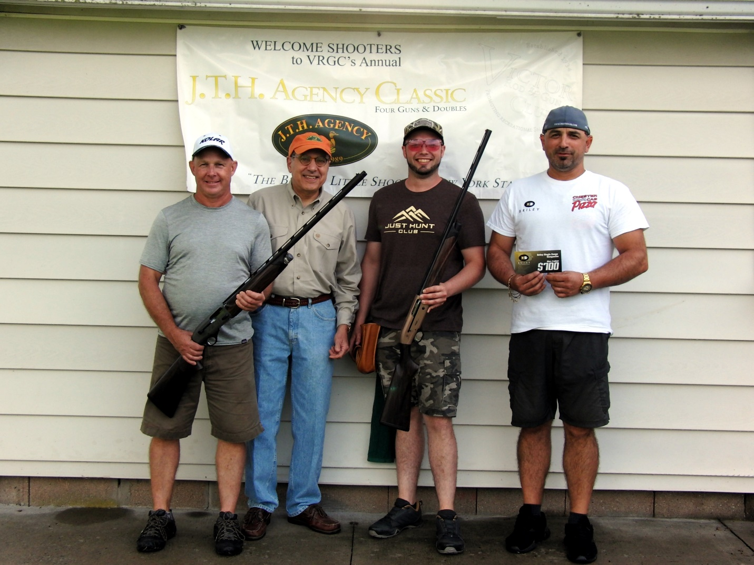
Victor, NY -- Victor Rod and Gun Club proudly hosted the 2022 JTH Agency Classic from June 10th to June 12th. This year’s event was the 33rd anniversary of this registered skeet tournament. It was the 18th consecutive year that John and Elizabeth Hessney, owners of the JTH Agency, sponsored the doubles and four-gun events. The Hessney’s were very generous (as they always are) providing over $6000 in added money and prizes for this year’s shoot. Shooters travelled from the Western New York region, Pennsylvania and Illinois to attend this well-respected tournament. We were delighted to have our Canadian friends be able to attend this year as the COVID border restrictions have eased.
The club members and shoot committee greeted the shooters. The VRGC website on-line registration helped speed the shooters through the registration process. After a volatile spring weather condition in the Rochester area, Mother Nature provided a very pleasant weekend for shooting. The clubhouse and grounds were in tournament condition due to the hours of preparation work by our club’s volunteers. The members take great pride in hosting this event. We always strive to live up to the shoot’s tagline as the “Biggest Little Shoot in New York State”.
Friday afternoon started the competition with 44 shooters in the doubles event. No shooter was able to run all the targets. Squad mates Dess Ivanov and Steve Wood each posted excellent scores of 98. In a short shoot-off, Dess prevailed as champ with Steve taking the runner-up spot. Class winners were Craig Parsons (AA), Scott Janowski (A), Mike Haff (B), Al Grundman (C), and Mike Kinsella (D). After the conclusion of the shooting, the shooters were treated to a happy hour and meal compliments of Jim and Hilda Thompson. Thanks Jim and Hilda!
Saturday’s weather cooperated with the shooters. The morning skies were partly cloudy with a little wind, but not bad for early summer in the Northeast. Fifty shooters took to the fields for Saturday’s competition with the .410 bore event first. No shooter was able to break 100 .410 targets. Brian (BJ) Jensen lost only one bird to finish with a field best of 99, claiming the champ’s title. Canadian Dan Morris and Pennsylvanian Mike Wojtecki posted 98s. Dan was runner-up after besting Mike in a shoot-off. Mike took the B class champ title. Other class winners were Dennis Lehman (AA), Don Lewandoski (A), Ron Casella (C), and John Yackiw (D).
The 20-gauge competition commenced on Saturday afternoon. Another full field of 50 shooter took to the fields. Mat Kelley and Clay Tietjen brought the first 100’s to the clubhouse. Mat triumphed as 20-gauge champ with Clay becoming the runner-up. After the shoot-off clay dust settled the class winners were Dan Morris (AA), Rick Laurito (A), Terry Prem (B), Guy Barr (C), and Joan Paddock (D).
This year, Pete Hamann generously donated $300 in added money for a special 20-gauge handicapped event for B/C/D class shooters only. Pete is the owner of Pete’s Stockworks & Shooting Supplies, LLC in Bloomfield, NY. (Please check out “Pete’s” either on-line or in person.) Guy Barr won this year’s special 20-gauge handicapped event with Doug Goodman and Kerry Henderson splitting the 2nd and 3rd place monies. Thank you, Pete, for your generous support of this event and for all that you do for the recreational shooting community.
At the conclusion of Saturday’s shoot-offs, the shooters, family members, and gun club volunteers all enjoyed a great happy hour and a succulent steak dinner donated by a group of Victor Rod and Gun Club members. The steaks were grilled to perfection, and all savored them to the last bite. Jim Hunter emceed the night’s events and got the festivities started. As a special note, Jim Hunter is one of the founders of this shoot. Thanks, JimBob for all of your contributions to this registered shoot over the past 33 years.
Sunday’s weather was ominous with a forecast that included possible thunderstorms. Undaunted, 50 shooters went to the fields to compete in the 28 gauge and 54 in the 12-gauge event. Much to the delight of the shooters the weather held off until near the end of day. First up was the 28-gauge event. The winds were calm and Ivanov and Wood took advantage by running all 100 targets. After a friendly shoot-off, Steve Wood came out the 28-gauge champ, with Dess Ivanov being the runner-up. Scott Janowski’s score of 99 earned him the AA title. Other class winners were Colin Smingler (A), Clay Tietjen (B), Mike Kinsella (C), and Joan Paddock (D).
Sunday afternoon featured the 12-gauge event. Three shooters, Ivanov, Morris, and Justin Aldrich crushed all 100 targets. After a very competitive and hard-fought shoot-off, Ivanov took home the 12-gauge title, with Morris being the runner-up, and Aldrich claiming the A1 title. Other class winners were Steve Wood (AA), Jim Reilly (B), John Yackiw (C), Todd Abbey (D), and Emily Streber (E).
As a special note, during the 12-gauge competition Don Lewandoski shot his 50,000th registered target. Congratulations Don!
For the third consecutive year, a 395x400 was the top HOA score. This year though, both Dan Morris and Dess Ivanov posted the 395s. Morris won the shoot-off to claim the 2022 JTH Agency Classic HOA title. Ivanov finished as the runner-up. The class winners were Mathew Kelley (AA), Clay Tietjen (A), Brian Jensen (B), Kerry Henderson (C), and Joan Paddock (D).
For the tenth consecutive shoot, the HOA competition featured the added handicapped HOA Challenge. All four gun shooters were eligible to enter this event. This event is named “Joe’s Challenge” in memory of Joe Strazzeri. Joe was a great skeet shooter and a stalwart of the Victor Rod and Gun Club. Sadly, we lost Joe to Pancreatic Cancer in November 2018. Joe was a great friend to all that knew him. He is greatly missed, but always remembered. Our shoot sponsors, John and Elizabeth added a bounty of prizes for this event including two Beretta shotguns and a Briley gift certificate. Needless to say, the event drew great interest from the shooters. The score board was watched closely at the conclusion of each event. When the results were all in, Clay Tietjen took home a 20ga. Beretta A400 ACTION shotgun, Dan Morris won the 12ga. Beretta A400XCEL shotgun and Dess Ivanov won the Briley gift certificate. Congrats to all winners of this year’s “Joe’s Challenge” handicapped HOA event.

Special thanks go out to our shoot chairman Andy Nolan who manages the shoot project. He has strong support from Keith, Max, Hilda & Jim T., John Y, Terry P, Ron B and many others. Also, thanks to Dan Caryl and the great crew of fine referees. We cannot thank shoot sponsors John and Elizabeth Hessney enough for their support and generosity. Each year they give back to the sport by sponsoring this fine shoot. John and Elizabeth are the owners and proprietors of the JTH Agency. They sell quality firearms, apparel, and accessories for the recreational shooting sports. Check out the store online at https://www.jthagency.com

We look forward to seeing you at the 2023 JTH Agency Classic!

